Nuachtlitir - Nollaig, 2021
Bhain na páistí an-taitneamh as an mbliots iománaíochta a bhí ar siúl sa pháirc Astra turf le déanaí. D’éirigh leo na scileanna a d’fhoghlaim siad a úsáid i gcluiche
The children really enjoyed the hurling blitz that took place in the Astra turf pitch recently and got a chance to put their skills to use in a game.

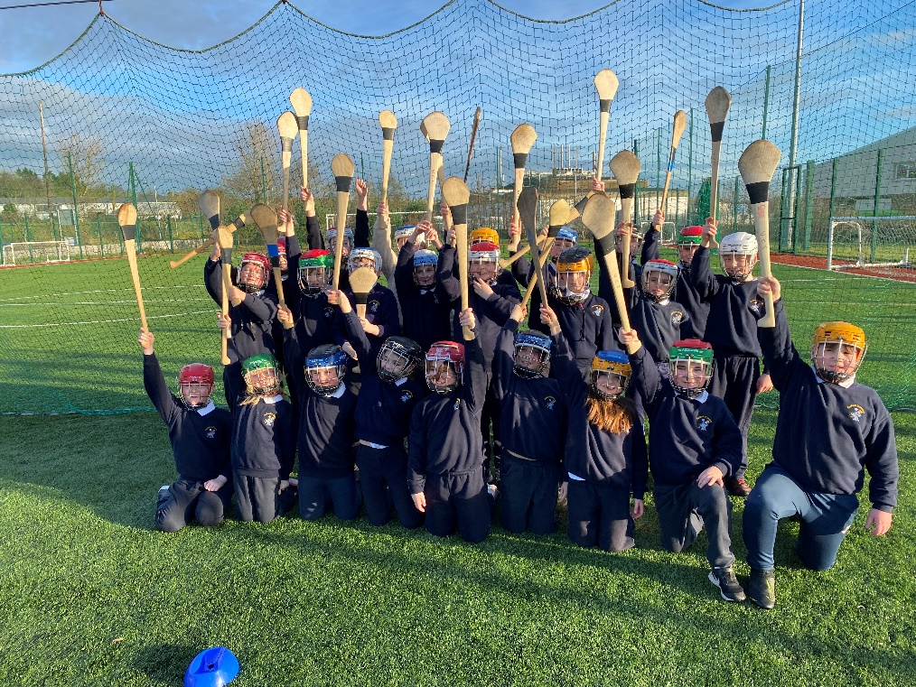

Thaitin an phéinteáil ar photaireacht le Ruth Uí Néill go mór leis na páistí freisin agus dhear siad pictiúir iontacha.
The children from all classes enjoyed the pottery painting with Ruth O’ Neill and created lovely designs.

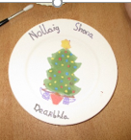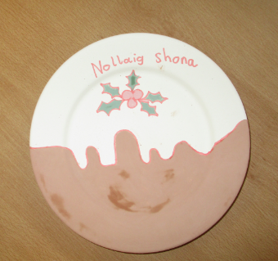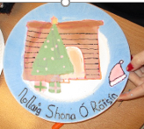

Míle buíochas libh as an airgead a thug sibh isteach don LauraLynn Foundation. D’éirigh linn €173 a bhailiú.
Sincere thanks for your support of the LauraLynn Foundation. €173 was collected altogether.

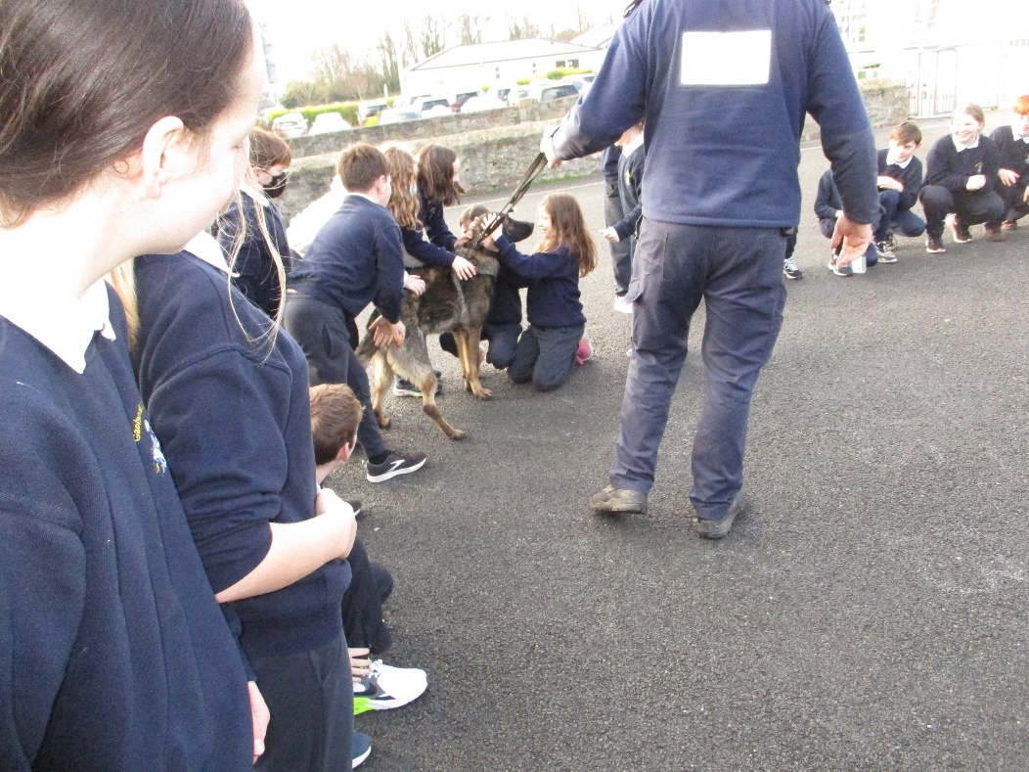

Bhaineamar an-taitneamh as an gcuairt ó Gharda Pat Harrington (Aonad Madraí, Corcaigh), Garda Eoin agus Garda Lisa Marie (Stáisiún na nGardaí, Cill Rois). Thug Pat an-eolas dúinn ar an obair a dhéanann madraí braite agus thaispeáin sé Laser, Rex agus Cody dúinn.

We really enjoyed our visit from Garda Pat Harrington (Dog Unit, Cork), Garda Eoin and Garda Lisa Marie (Kilrush Garda Station). Pat told us all about the work of sniffer dogs and the children got to rub Laser, Rex and Cody.

Tháinig cuairteoir speisialta chuig an scoil roimh Nollaig. Chuala sé go raibh na páistí sa scoil go hiontach agus bhí bronntanas aige do gach duine.

We had a special visitor before the holidays. He said that he had been told that the children in the school were really good and so he had a present for everybody.

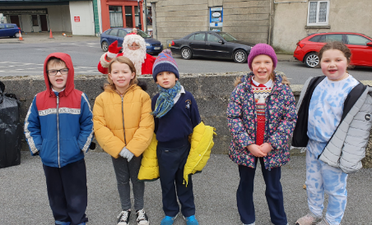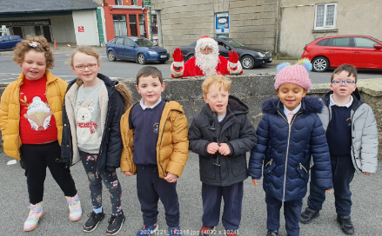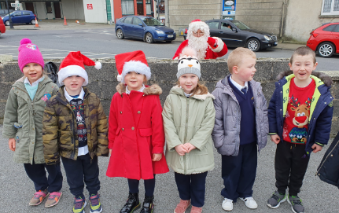
Míle buíochas leis na daoine a cheannaigh línte do Chrannchur na Nollag. D’éirigh linn €692 a bhailiú. Comhghairdeas leis na daoine a leanas a bhuaigh duaiseanna:
Sincere thanks to all who supported our Christmas raffle. We collected €692. Congratulations to the following who won prizes:
Gerard Clohessy, Thomas Whelan, Tracey O Dea, Ella Morgan, Stephen Little, Joe Carrig,
Chris Gilligan, Aine Cotter, Mick Kiely, Katy Guona Barre, Christian Edgeworth, Robbie

Hall, Nina Walsh Finnerty and Ruby Crowley.

Beimid ar ais ar scoil ar an Déardaoin 6ú Eanáir./ We will return to school on Thu 6th January.

Beannachtaí na Nollag oraibh go leir.

