Nuachtlitir - Márta 2022

Comhghairdeas leis na páistí i rang a sé a fuair a gCóineartú ar an Satharn 12ú Márta - Iseult Ní Dhónail, Kara Ní Shé, Dylan Mac Lúcáis, Eoin Mac Lúcáis, Eoin de Búrca Dearbhla Ní Ailbhí, Fionn Ó hAilbhí, Dónall Mac Fhloinn, Shane Ó Faoláin, Sophie Ní Chathail agus Sorcha Ní Chearmada. Bhí siad ar fheabhas ag canadh, ag léamh agus ag seinnt. Míle buíochas leis na páistí as Rang 2, 3, 4 & 5 a bhí ag canadh sa chór. Bhí siad thar barr.
Congratulations to the sixth-class children from the Gaelscoil who received the sacrament of Confirmation on Saturday 12 March. They sang, read and played beautifully. Well done to the singers from 2nd, 3rd, 4th and 5th class who sang in the choir on the day. They were wonderful.

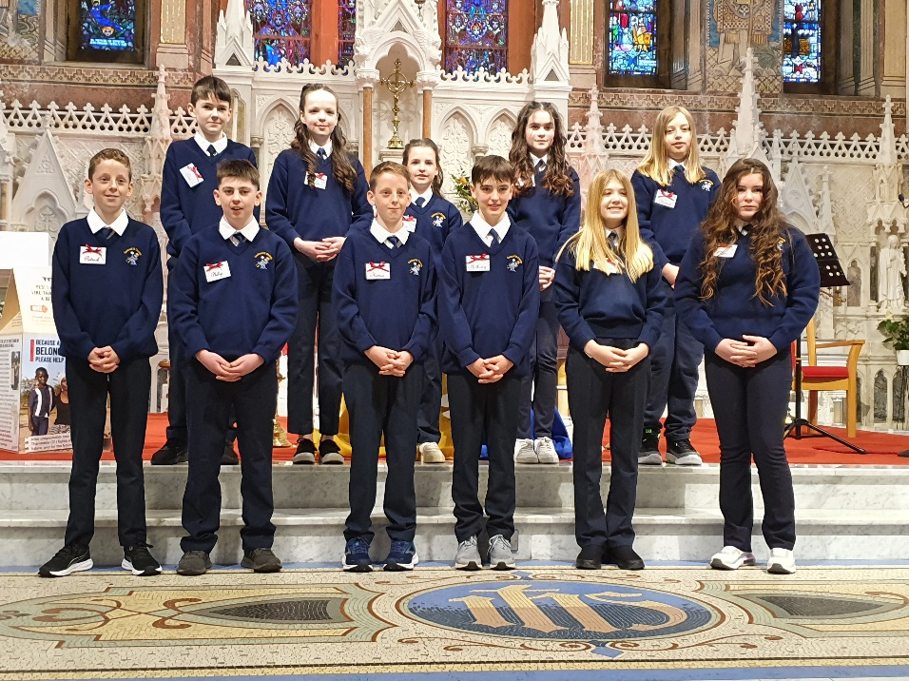

Comhghairdeas leis an scoil a bhain an dara háit amach sa mhórshiúl Lá ‘le Pádraig. Bhí siad go hiontach ar fad. Míle buíochas leis na daoine a chabhraigh linn leis na hullmhúcháin roimhré agus dóibh siúd a chabhraigh linn ar an lá. Míle buíochas !
Congratulations to all involved in the St Patrick’s Day Parade. Winning second place in the Creative section was a wonderful achievement and we were very proud. Sincere thanks to all who helped out with the preparations beforehand and to all who helped out on the day. Well done!

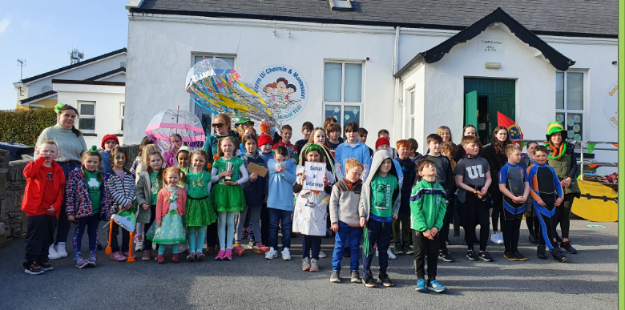
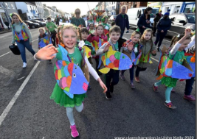

Fuair na páistí i Rang a dó Sacraimint na hAithrí ar an Luan 28ú Márta. Bhí siad ar fheabhas. Míle buíochas leis an gcór as canadh agus seinnt dóibh.
The Second-class children received the Sacrament of Reconciliation on Monday 28th March. They were wonderful. Thanks to the choir for adding to the occasion with music and song.
Thugamar tacaíocht don Ukraine Appeal ar an gCéadaoin 16ú Márta nuair a bhí lá gan éide scoile againn. Bhailíomar €363.30.

We supported The Ukraine Appeal on Wed 16th March by holding a non-uniform day and €363.30 was collected.

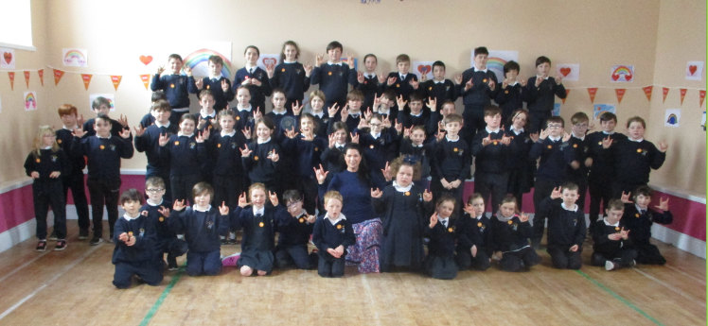
Bhain Rang 2 – 6 an-taitneamh as na ranganna teanga comharthaíochta le Helen Ball. Don rang deireanach chan siad ‘Rainbow Connections’ sa halla ag síniú na focail. Bhí na Naíonáin Bheaga, Naíonáin Mhóra agus Rang 1 ag canadh freisin agus bhí sé go hálainn.
The sign language classes for Rang 2 - 6 with Helen Ball were enjoyed by all. For the final class the children sang the song ‘Rainbow Connections’ while they signed the words. Junior Infants, Senior Infants and First class joined in for this. It was beautiful. We decorated the hall for the occasion.
Tréaslaímid le Kara Ní Shé a roghnaíodh le himirt san INTO Mini 7’s i bPáirc an Chrócaigh toisc gur imir sí thar barr sna trialacha in Inis le déanaí. Is í duine den bheirt as Co an Chláir atá ag dul ar aghaidh.
A huge congratulations to Kara O’ Shea who, because of her excellent display at the Girls’ Football trials in Ennis, was one of the two girls from Clare nominated to play in the INTO Mini 7’s in Croke Park on All-Ireland semi and final days. Well done!
Tá Gaelscoil Uí Choimín tar éis Stadas DEIS a fháil. ‘Sé is brí le sin ná go bhfaighidh an scoil tacaíocht ó thaobh acmhainní de, do litearthacht agus uimhearthacht. Chomh maith le sin beidh méadú ar an maoiniú a gheobhaidh an scoil. Beidh níos mó bia ar fáil do pháistí faoin scéim seo freisin.
Just recently Norma Foley announced that Gaelscoil Uí Choimín will be included under the DEIS (Delivering Equality of Opportunity in Schools) programme where the school will be able to access literacy and numeracy supports to help educational disadvantage and it will also receive increased funding. Additional food will also be provided under this scheme.

Tá foireann pheile na scoile ag traenáil go dian faoi stiúir Gordon Ó Droma na laethanta seo.
Our football team are training with Gordon Drummy for this year’s Cumann na mBunscol games.
Tá na foirne cispheile ag traenáil freisin le Máirtín Ó Ruiséil don chomórtas Marion Keane a bheidh ar siúl ar an gCéadaoin.
Our basketball teams are also training for the Marion Keane competition under the guidance of Martin Russell - competition takes place this Wednesday.
Bhuail baill d’fhoireann na scoile leis an bhfoireann dheartha maidir leis an scoil nua. Foirgneamh le ceithre seomra ranga a bheidh i gceist. Deanfar trí dhearaidh agus seolfar iad chuig an Roinn Oideachais agus roghnóidh siad an ceann a oirfidh dúinn.
Members of the staff met with the school design team recently. Three designs for a four-classroom school will be drawn up in consultation with the school and these will be submitted to the Department of Education. The Department will choose the design that they think will be most suitable for our needs.

Dátaí Tabhachtacha:

Céad Chomaoineach: Satharn 21ú Bealtaine 11 r.n./ First Holy Communion Saturday 21st May at 11 am.

Laethanta Saoire na Cásca 8ú Aibreán 12 a chlog. Tiocfaidh na páistí ar ais ar an Luan 25ú Aibreán.

Easter Holidays: Friday 8th April at 12 noon. Children return to school on Monday 25th April.

Beannachtaí na Cásca oraibh go léir.

