Nuachtlitir – Feabhra 2022
Rinne na páistí crosóga Bhríde in onóir do Naomh Bríd ar an gcéad lá d’Fheabhra.
The children made St Brigid’s crosses on the 1st February in honour of St Brigid.
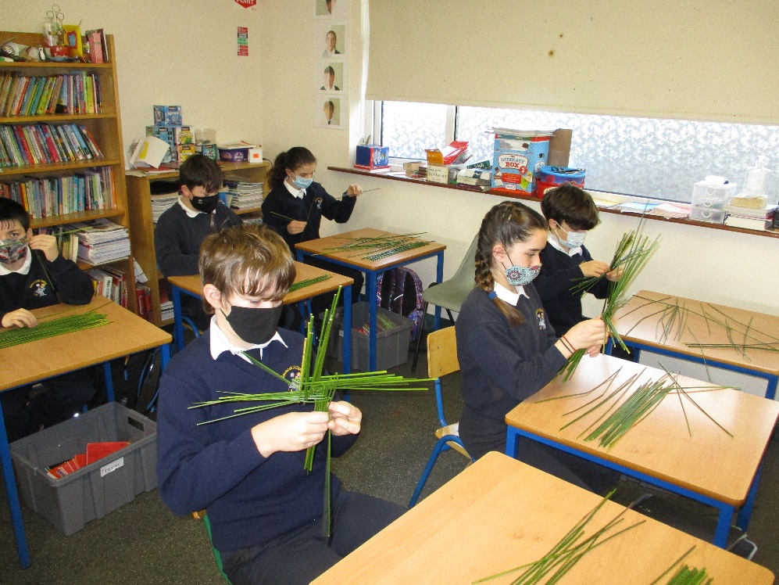

Beidh ranganna scileanna iománaíochta do gach rang ag tosú arís ar an gCéadaoin 9ú Márta. Beidh siad ar siúl sa halla i rith am scoile.
Children from all classes will take part in fundamental hurling skills again starting this Wednesday 9th March. These will take place in the hall during school time.

Beidh Cóineartú do Rang 6 ar siúl ar an Satharn 12ú Márta agus tá siad ag ullmhú go dian. Beidh na páistí ó Rang 2 - Rang 5 ag canadh linn ar an lá agus tá an-chleachtadh déanta acu agus tá siad an-bhinn.
6th class are preparing for their Confirmation that will take place on Sat 12th March. Children from 2nd – 5th class make up the choir that will be singing on the day and they have been practising regularly and sound very sweet.

Tá na ranganna teanga comharthaíochta beagnach críochnaithe. Don rang deireanach inniu beimid ag canadh ‘Rainbow Connections’ agus ag síniú na focail. Beidh Naíonáin Bheaga, Naíonain Mhóra agus Rang 1 ag canadh linn agus táimid ag súil go mor leis
The sign language classes are almost at an end. For our final class today we will be singing the song ‘Rainbow Connections’ while we sign the words. Junior Infants, Senior Infants and First class will be joining the other classes for this finale.
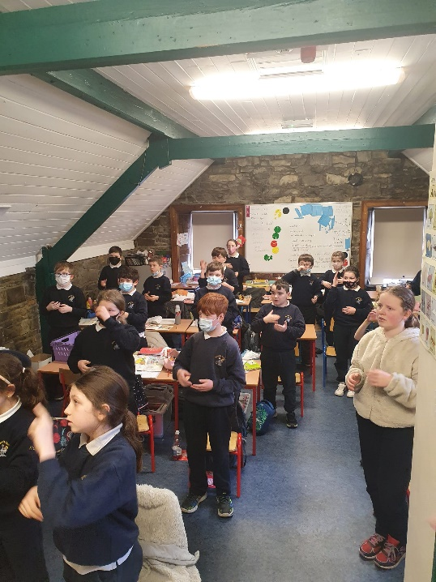

Beidh an scoil ag glacadh páirte sa chlár ‘Food Dudes 16 Day Healthy Eating Intervention Programme’ an téarma seo chugainn. An aidhm atá le seo ná páistí a mhealladh chun níos mó glasraí agus torthaí a ithe. Seolfaidh Bord Bia éagsúlacht glasraí agus torthaí chuig an scoil agus beidh seans ag na páistí iad a ithe.
The school will be participating in the ‘Food Dudes 16 Day Healthy Eating Intervention Programme’ next term. The programme is designed to increase children’s consumption of fruit and vegetables. Bord Bia will provide a variety of fruit and vegetables to the school for the children to eat.

