Nuachtlitir Deireadh Fómhair 2022
Bhain Rang 1 agus Rang 2 an-taitneamh as an bhficheall a bhí ar siúl sa leabharlann le déanaí. D’fhoghlaim siad na rialacha agus d’imir siad cluichí simplí.

Rang 1 agus 2 really enjoyed their trip to the library recently where they learned the basic rules of chess and played simple games.

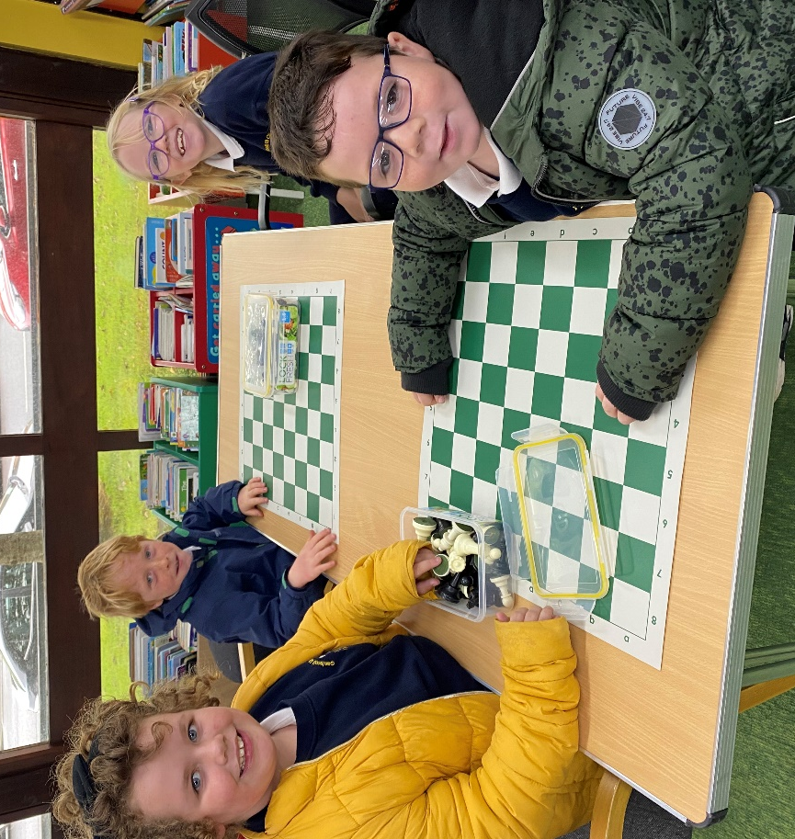

Chaith Rang 5 agus 6 mí ag freastal ar ranganna ar an bhfeadóg stáin san Ionad Pobail. D’fhoghlaim said poirt nua agus conas rollaí a chur le nótaí.

Rang 5 agus 6 attended tin whistle classes in the Community centre and learned new tunes and how to add ornamentation to tunes.

Táimid ag glacadh páirte san ‘Christmas Shoebox Appeal’. Caithfidh na boscaí a bheith istigh ar an 8ú Samhain

The school will be taking part in the ‘Christmas Shoebox Appeal’ again this year. You are asked to have boxes in by 8th Nov.

Beidh ranganna Fraincise agus Gearmáinise ag tosú i ndiaidh briseadh na Samhna.

French and German classes will begin during school directly after Halloween.

Cuirimid fáilte roimh Mhúinteoir Clodagh atá tosnaithe linn mar mhúinteoir HSL (Home School Liaison). Tá a post roinnte idir an Ghaelscoil agus Scoil Naomh Iósaf i gCill Chaoi.

We welcome Muinteoir Clodagh who has joined our staff as a HSL (Home School Liaison) teacher shared between us and St Joseph’s Secondary School, Kilkee.

Tá na páistí ó Rang 2 - 6 ag baint taitnimh as na ranganna veidhlín agus tá an-chleachtadh ar siúl acu.

Children from Rang 2 – 6 are enjoying the violin classes and are putting in lots of practice.

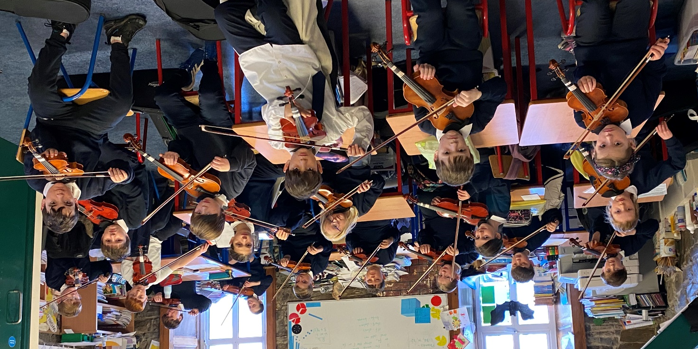

Bain taitneamh as briseadh na Samhna!

